Design an e-Commerce Application

**FLOW DIAGRAM:**

**AWS Services Implemented:**

**ECS:** Deployed FE and backend code in EC2 using AWS Fargate

Amazon elastic container service is a fully managed service which is provided by AWS it is mainly used to deploy containers that are docker based by which you scale up and down depending on the traffic you’re going to get. The containers will run inside the Amazon elastic cloud (EC2) instance.

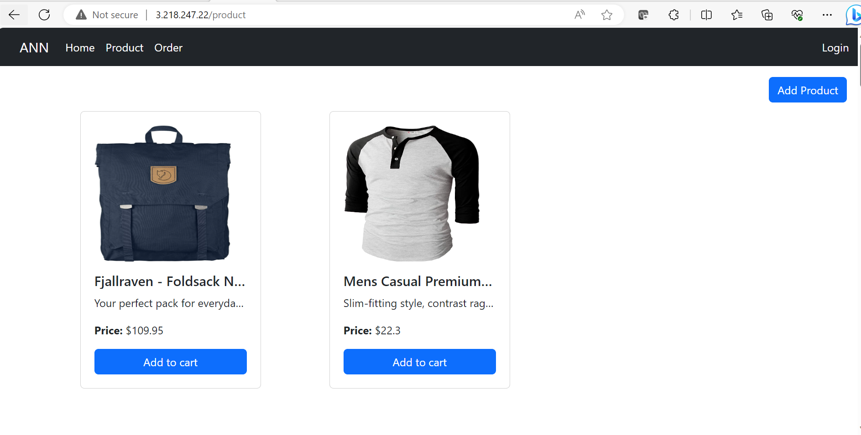

**RDS:** Used PostgreSQL for storing and retrieving data.

It is one of the most popular databases supporting JSON (non-relational) queries and SQL for (relational) queries.

**S3:**  Used to store image of the products.

S3 stands for Simple Storage Service. It is Object-based storage, i.e., you can store the images, word files, pdf files, etc. It has unlimited storage means that you can store the data as much you want.

**SNS:**  Used to send notification to the user when the product is added in S3.

